DOI: 10.1002/ admt.201800135

**Article type: Full Paper**

Free-standing electrodes derived from metal-organic frameworks/ nanofibers hybrids for membrane capacitive deionization

Meng Ding, Kranthi K.R. Bannuru, Ye Wang, Lu Guo, Fuming Chen, Avinash Baji, Hui Ying Yang*

M. Ding, K. K. R. Bannuru, Dr. Y. Wang, L. Guo, Dr. F. Chen, Prof. A. Baji, Prof, H. Y. Yang

Pillar of Engineering Product Development (EPD), Singapore University of Technology and Design, 8 Somapah Road, 497372, Singapore

*E-mail: [yanghuiying@sutd.edu.sg](mailto:yanghuiying@sutd.edu.sg)

Dr. Y. Wang

Key Laboratory of Material Physics of Ministry of Education, School of Physics and Engineering, Zhengzhou University, Zhengzhou 450052, PR China

Keywords: Metal-organic frameworks, Carbon nanofiber hybrid, Membrane capacitive deionization

Membrane capacitive deionization has been considered as a promising technology for water treatment with their high efficiency, low capital cost, and environmental friendliness. However, the complex fabrication process of membrane capacitive deionization electrodes mainly hinders its viability in large-scale applications. In this study, we present a facile and general method to prepare free-standing electrodes for membrane capacitive deionization with an excellent electrosorption performance. The electrospun nanofibers enclosing zinc-based nanoparticles are fabricated as the templates. After pyrolysis, the nitrogen-doped carbon nanofiber hybrids with high conductivity and a high surface area can be obtained readily. The carbon electrode material is able to achieve a salt adsorption capacity of 43.3 mg g-1 at 1.4 V in 1000 mg L-1 NaCl aqueous solution. Overall, the carbon nanofiber hybrids electrode prepared by electrospinning and pyrolysis shows a great potential in membrane capacitive deionization for industrial applications.

1. **Introduction**

Access to clean and reliable fresh water supply has been considered to be a universal human right yet also a grand challenge for the world.[1] As the continuous developing of urbanization and growth of population, the demand for fresh water will become even larger.[2] Instead of exhausting the worldwide fresh water reserves, the increasing demand can be compensated with sustainable resources. Water desalination method is a possible solution to alleviate the current stress of fresh water shortage.[3] Compared with traditional desalination technologies, such as evaporation (distillation)[4] and reverse osmosis[5], capacitive deionization (CDI) as a promising desalination method has attracted much attention in recent decades.[6, 7] As an energy-efficient and environmental-friendly approach, CDI depends on electrical double layers (EDLs) formed at the carbon-based electrode surface to absorb ions from feed solutions.[8] Membrane capacitive deionization (MCDI) is an improved method from CDI by simply integrating ion-exchange membranes (IEMs), in which an anion-exchange membrane is tightly fixed in front of the anode, and a cation-exchange membrane is for the cathode. In MCDI process, the counter-ions can migrate to the electrode more effectively. And the co-ions on the electrode surface are preserved which further increases the salt adsorption capacity and charge efficiency.[9]

Another advanced improvement for CDI and MCDI is the innovation of electrode materials. It has been proven that porous carbon materials with a high specific surface area and good electrical conductivity are generally favorable for electrosorption performance where the EDLs are easier to form.[8] Since 1990s, various kinds of carbon materials have been studied as electrode materials for CDI and MCDI, including carbon aerogels[10], carbon nanotubes[11, 12], activated carbons[13], carbon nanofibers[14], carbon composites[12, 15], etc. Recently, porous carbons derived from metal-organic framework (MOF) have shown greatly enhanced performance in desalination due to their large surface area and uniform morphology.[16, 17] Moreover, the synthesis process for certain MOFs are facile and applicable in industrial manufacturing. For example, a zeolitic imidazolate framework (ZIF), ZIF-8, is able to produce porous carbon polyhedral with a large surface area of 1187.8 m2 g-1 and exhibits a high salt adsorption capacity of 13.86 mg g-1 in a CDI system.[16] However, the carbon derived from ZIF-8 has a low electrical conductivity that reduces the charge efficiency for the adsorption process. In our prior work, we improved the electrical conductivity of carbon derived from ZIF-8 by fusing another MOF called ZIF-67. ZIF-67 is a cobalt-based MOF that can catalyse graphitic carbon during pyrolysis.[18] With the improved conductivity, the porous carbons derived from Zn- and Co-based bimetallic MOF achieve a high salt adsorption capacity of 45.62 mg g-1 for MCDI.[19] Besides suffering from a low electrical conductivity, porous carbon derived from ZIF-8 has a severe aggregation during the pyrolysis process, which decreases the specific surface area and impedes the diffusion path for salt ion into the microporous structure. Hence there is still room for us to improve the desalination performance of ZIF-8 related electrode materials. For example, Pan *et al.* reported a ZIF-8 derived carbon/carbon nanotubes composites to enhance the electrical conductivity and modify the pore structure, which exhibit an improved adsorption capacity of 20.5 mg g-1 in CDI.[17]

In this work, we focus on designing a kind of carbon nanofiber composites with carbon nanoparticles derived from ZIF-8 by a general and simple technique. The one-dimensional (1D) carbon fibers serve as conductive tunnels to enclose the porous carbon nanoparticles which are able to enhance the electrical conductivity and reduce the aggregation of MOF-derived carbon particles. The carbon nanofiber composites were prepared by electrospinning using polyacrylonitrile (PAN) and ZIF-8, and then annealing in the nitrogen atmosphere. After annealing under high temperature, ZIF-8 nanoparticles were decomposed and carbonized with nanofibers to form interconnected nitrogen-doped (N-doped) carbon hollow nanofibers. The 1D carbon nanofibers are capable to inhibit the congregation of nanoparticles and benefit to electron transport.[20] And the porous structures can reduce the ion diffusion pathway and provide sufficient sites for ion adsorption.[21] Moreover, the mechanical strength and flexibility of the carbonized samples are fairly good that are able to serve as free-standing electrode materials without polymer binders or conductive substrates, which further simplifies the fabrication process and reduces the cost.[22] It is demonstrated that the electrodes derived from MOF/nanofiber hybrid have an enhanced desalination performance of 43.3 mg g-1 at 1.4 V in 1000 mg L-1 NaCl aqueous solution. The reliable cycle performance (≥32 cycles) further demonstrates its great potential for industrial applications.

1. **Results and Discussion**

The schematic illustration for the synthesis process of carbon nanofiber hybrid (CNFH) is shown in **Figure 1**. Firstly, the precursor solution of PAN was mixed with uniformly dispersed ZIF-8 powders and transferred into nanofibers by electrospinning. The as-prepared nanofiber composite film was firstly stabilized at 280 °C in the air and then annealed in a tube furnace at 1,000 °C in N2 atmosphere (**Figure S1**). During the pyrolysis, the organic ligands in ZIF-8 and PAN molecules were converted into N-doped carbon since the nitrogen species are retained in the organic ligands.[23] And the zinc species were reduced to metallic Zn by carbon and eventually evaporated at 908 °C, which is the boiling point of Zn.[24] The elimination of Zn ions has created porous structures in CNFH sample. As to the carbon nanofiber (CNF) sample, it was prepared directly from the electrospinning nanofibers of PAN without ZIF-8 nanoparticles.

The morphology and structure of CNF and CNFH were examined by a field-emission scanning electron microscope (FESEM) and a transmission electron microscope (TEM), as presented in **Figure 2**. It can be observed that the prepared CNF is fairly long with uniformed diameters around 400 nm and the sample surface is quite smooth without apparent fractures (Figure. 2(a), 1(b)). And the TEM image of CNF in Figure 2(c) reveals its solid structure of amorphous carbon. As to CNFH, the diameter is similar with that of CNF but the surface is relatively bumpy and distorted (Figure 2(d), 2(f)). This is due to the well-dispersed carbon nanoparticles derived from ZIF-8 within the nanofiber structure. The Zn2+ sites of ZIF-8 are joined with the -C≡N bands in PAN, leading a tight enclosure of MOF-derived carbon nanoparticles in nanofibers.[25] The corresponding TEM image shown in Figure 2(e) confirms the isolated hollow carbon nanoparticles, which reveals the successful synthesis of MOF-derived carbon nanoparticles with carbon nanofibers as the conductive tunnels. The hollow structure is constituted by the decomposition of ZIF-8 from inside to outside at high pyrolysis temperature.[25, 26] The insert of Figure 2(d) reveals the extraordinary flexibility of the CNFH free-standing electrode. Even bent for dozens of times, the structure was still maintained well, showing the high mechanical strength of CNFH samples.

The carbon structures of CNF and CNFH were analysed by the X-ray diffraction (XRD) shown in **Figure 3**(a). Two broad peaks around 26° and 43° are found in the XRD patterns of both samples, corresponding to the (002) and (100) carbon diffraction peaks respectively[26, 27]. The XRD pattern of CNFH reveals that the (002) peak has an notable upshift of 2° from 26°, suggesting the integration of nitrogen atom in the graphitic structure.[28] Nitrogen-doping has been considered as a promising method to improve the electrical conductivity and induce defects for the electrode materials.[29] With a large amount of nitrogen-doping in our CNFH electrodes, the desalination performance is expected to be enhanced due to the increased ion-accessible surface area from defects and the faster charge transfer.[30] The XRD pattern of embodied ZIF-8 nanoparticles is shown in **Figure S2**. By examining and comparing with the simulated pattern observed from the published ZIF-8 structure data[31], we can confirm the pure phase of the ZIF-8 samples as synthesized.

We further investigated the elemental bonding and composition of obtained carbon materials using X-ray photoelectron spectroscopy (XPS). The XPS spectra indicate the existence of C, N and O elements in the above samples shown in Figure 3(b). The elemental composition ratio is shown in **Table S1**. No zinc species were found in CNFH samples after high-temperature pyrolysis. The high-resolution C1s XPS spectra of C1s spectra for CNF and CNFH are shown in **Figure S3**(a) and S3(b), which can be resolved into sp2 carbon (284.8 ± 0.1), the combination of C-N bond with sp3 carbon (284.8 ± 0.1), and N-C=O bond (289.1 ± 0.2). The position of the main peak sp2 carbon confirms the existence of graphite structure of carbon in the above carbon samples.[32] As seen in Figure 3(c) and 3(d), the high-resolution of N1s spectra of the above samples are resolved into four peaks including pyridinic N (398.3 ± 0.3 eV), pyrrolic N (400.5 ± 0.3 eV), graphitic or quaternary N (401.6 ± 0.2 eV) and terminal N-O bond (403.9 ± 0.2 eV). Pyridinic N and pyrrolic N are the domain N content in the above carbon samples. Pyridinic N stands for the nitrogen atom that substitutes a carbon atom in a C6 ring and bonds with two sp2 carbon atoms. And pyrrolic N represents the nitrogen atom in a five-member ring and donates two electrons to the π bond. Graphitic N is also called as quaternary N, which is mostly located inside the graphitic carbon plane and bonds with three sp2 carbon atoms.[33] The terminal N-O peaks are attributed to the chemisorbed nitrogen oxide on the graphite layers.[34] It has been proven by simulation and experiments that the graphitic N can improve the electronic conductivity of carbon materials.[35] Moreover, pyridinic nitrogen and pyrrolic nitrogen are able to increase the pseudocapacitance.[36] The doped N atoms located at the edges of graphene layers are possible to improve the wettability of carbon surface.[37] As shown in the XPS results, nitrogen atoms are widely doped within the carbon fiber matrix, which is expected to facilitate the electron transport through the electrode materials and improve the capacitive behavior.[38, 39]

The specific surface area and porosity were characterized by nitrogen sorption isotherms and pore size distribution (Figure 3(e) and 3(f)). According to the classification of the International Union of Pure and Applied Chemistry (IUPAC), the pathways of CNF and CNFH sorption curves (Figure 3(e)) are basically type I with H4 hysteresis loops indicating a wide range of pore size distribution in the carbon structures.[40] And the specific adsorption capacity of nitrogen shows the difference in surface area of CNF and CNFH. CNFH exhibits an improved surface area (696.2 m2 g-1) compared with CNF (378.8 m2 g-1) due to the incorporation of porous carbons derived from ZIF-8. As seen from Figure 3(b), the volume amount of micro- and mesopores for CNFH samples is much higher than that of CNF. Here the average pore size of CNFH and CNF are 1.966 nm and 1.851 nm. And the pore volume of CNFH (1.499 cm3 g-1) is greater than that of CNF (0.762 cm3 g-1), with the increased amount of micro-/mesopores (Table S1). It is known that both of micro- and mesopores can contribute to the electrosorption of salt ions: micropores increase the contact area of ions and the EDL regimes, and mesopores improve the ion accessibility to the electrodes.[41, 42] An enhanced specific surface area and a wide range of pore size distribution of CNFH samples are favorable for a superior salt adsorption performance.

As the ion adsorption of MCDI systems is based on the formation of EDLs, the electrochemical measurements based on NaCl aqueous electrolytes are considered as effective approaches to evaluate the salt adsorption ability of electrode materials.[43] We conducted cyclic voltammetry (CV) and electrochemical impedance spectroscopy (EIS) for the electrochemical measurements in 1 M of NaCl aqueous solution using a 3-electrode setup. **Figure 4**(a) is the CV curves of CNFH under different scan rates from -0.1 V to 0.9 V, presenting regular rectangular shapes which are corresponding to the capacitive response from EDLs. Operation potentials were determined with respect to a saturated calomel electrode (SCE). In comparison, the CV curves of CNF (**Figure S4**) under different scan rates have similar shapes yet with reduced capacitances. Apparently, in Figure 4(b) the area surrounded by CV curve of CNFH at 20 mV s-1 is larger than that of CNF, suggesting an improved capacitance of CNFH. Based on the calculation from CV curves, a comparison of specific capacitance (*Cs*) for the above samples is shown in Figure 4(c) and the data is listed in **Table S2**. With the scan rate ranging from 1 mV s-1 to 100 mV s-1, *Cs* values of the obtained carbon samples show decrease trends yet *Cs* of CNFH is higher than that of CNF consistently. The highest *Cs* of CNFH is 172.7 F g-1 which was achieved under a scan rate of 1 mV s-1. The improved capacitance can be explained by the increased surface area from the inserted porous carbons.[17]

The electrical conductivity of our carbon samples was investigated by EIS tests. Nyquist plots of CNF and CNFH, illustrated in Figure 4 (d), include a small semi-circular curve at the low frequency, and a straight line at the high frequency. The insert of Figure 4 (d) shows the equivalent circuit for the EIS data. The initial point, the semicircle and the straight line are related to the resistance of intrinsic components (Rs), charge transfer from the carbon structure to the interface (Rct), and the ion diffusion process (Ztl), respectively. Qct is a constant phase element in parallel with Rct.[44] The impedance data simulated based on the Nyquist plots are summarized in **Table S3**. The values of Rs of CNF and CNFH are 0.18 Ω and 0.19 Ω. And Rct of CNF (1.16 Ω) is much lower than that of CNFH (1.81 Ω) due to the better quality of graphitic carbon structures. Moreover, the slope of the straight line in CNF Nyquist curve is larger than that of CNFH, indicating a faster ion diffusion process.[45] In comparison with a previous report (2.10 Ω)[17], the impedance of CNFH is reduced compared with porous carbon derived from ZIF-8, further confirming the improved conductivity of CNFH by enclosing nanoporous carbon with CNF. The nanoporous carbon particles derived from ZIF-8 are tightly wrapped within the CNF structure, acting as a highly conductive pathway for the charge transport and ion diffusion process throughout the electrochemical tests. The enhanced electrochemical behavior of CNFH suggests a promising desalination performance in an MCDI system.

To investigate the electrosorption performance of CNF and CNFH samples, a series of batch-mode MCDI tests were carried out. The free-standing electrodes made from the above samples were tested under different electrical potentials (0.8 – 1.4 V) in NaCl aqueous solution with various initial concentration (250 – 1000 mg L-1). The conductivity change (μS cm-1) of the treated solution was recorded continuously during the test as well as the corresponding current. **Figure 5**(a) presents a complete cycle of the electrosorption tests for CNF and CNFH conducted at 1.2 V in 500 mg L-1 NaCl aqueous solution. As seen in this plot, the conductivity value for both electrode materials firstly decreases during the charging process (40 min) and then returns to initial concentration for the discharging process (20 min). Specifically, the CNFH electrodes achieve an enhanced electrosorption behavior with a faster ion removal rate and a greater number of adsorbed ions. Although the CNFH has an inferior electrical conductivity, it benefits from the hierarchical porous structure where a larger number of micropores can store more salt ions effectively.[8, 46] For each condition, the electrode materials have been tested for three times at least. The error bar presented in this article indicates the mean ± standard error mean (n = 3). In **Figure S5**, the salt adsorption capacities (SAC, *Γ,* mg g-1) of CNF and CNFH electrodes as a function of applied voltages are calculated to compare their electrosorption performance straightforwardly. *Γ* is the mass ratio of NaCl molecules adsorbed in the electrodes to the active materials of the electrode, regarding as one of the important metrics to evaluate the MCDI electrode materials.[7] The plot of *Γ* values in Figure S5 is obtained based on desalination tests in the solution with an initial concentration of 1000 mg L-1. The adsorption capacities of CNFH and CNF in different initial concentration solutions are presented in Figure 5(b) and Figure S5, respectively. It is seen that the *Γ* value of CNFH is higher than that of CNF, confirming the better electrosorption performance of CNFH electrodes. Compared with the porous carbons derived from ZIF-8 in previous work, CNFH also shows an improved result. A detailed summary of the results is shown in **Table 1**.[16, 54, 17, 19]

Figure 5(b) illustrates the desalination processes of CNFH electrodes at different applied voltages. The conductivity decreases faster and deeper as the voltage increased for the charging process as well as the corresponding current. The CNFH electrodes are also tested in NaCl solutions with the initial concentration ranging from 250 to 1000 mg L-1. As seen in Figure 5(c), the *Γ* value of CNFH electrodes increases gradually as the concentration and applied voltage become greater. In the NaCl solution with a higher concentration, the ion concentration in the EDLs grows larger and the ionic resistance becomes lower, leading to an increased *Γ* value.[47] As shown in Figure S6, the *Γ* value of CNF electrodes also presents a similar trend in different initial concentration solutions. Charge efficiency (*Λ*, %) is defined as the molar ratio of ions removed from the solution to the electrons transfer during the charging process, which is also an important parameter to assess MCDI performance.[48] As the co-ion expulsion effect can be restrained by ion-exchange membranes, *Λ* values of CNF and CNFH in MCDI are relatively high compared with other CDI electrodes (Figure 5(d)).[9] Especially, CNFH electrodes remain a high *Λ* value in different cell voltage (>75%) in 500 mg L-1 NaCl aqueous solution, indicating efficient desalination processes. And the dependence of charge efficiency on initial concentration as shown in **Table S4** suggests a decreasing trend with an increasing concentration due to the stronger ionic strength in higher concentration solutions.[48]

Moreover, good durability is also very important for MCDI electrode materials especially in practical applications.[8] To evaluate the stability of CNFH electrodes in desalination processes, a long-term MCDI experiment was carried out. Figure 5(e) depicts an excellent cycle performance of CNFH electrodes. It is illustrated that over 32 cycles of charging-discharging processes were done continuously without obvious decays with stable salt adsorption capacities. The capacity retention remains around 100%, indicating a reliable desalination performance in long-time cycling. The slight increase in the conductivity is caused by the water evaporation during a long-time operation. A similar phenomenon was observed in another work.[49] It has been proven that some faradaic reactions such as the electrochemical oxidation of the carbon materials can result in the deterioration of electrode stability and performance. However, compared with traditional CDI, MCDI test shows less oxygen content and carbon loss after cycling which is more favourable for long-term operations.[50] Hence, in our desalination experiments, the stable cycling ability of CNFH electrodes can be ascribed to not only the favourable properties of the electrode material but also the operation mode of MCDI.

To investigate the kinetic performance of CNF and CNFH in MCDI processes, the Kim-Yoon diagram (KY-diagram, as known as Ragone plot) of average salt adsorption rate (ASAR) versus salt adsorption capacity (SAC) as shown in **Figure 6**(a) was utilized to compare the desalination rates between CNF and CNFH in 250 mg L-1 NaCl solutions.[7, 51] In general, a higher salt adsorption with a faster salt adsorption rate of the electrodes show a shift to the upper and right side in KY-diagram.[40] Apparently, the CNFH electrode exhibits an improved desalination capacity and rate compared with that of CNF due to an increased amount of micropores and mesopores in the carbon structure.[42] Figure 6(b) is a KY-diagram of CNFH adsorption results under different applied voltages. As can be seen, the plot shifts gradually to the upper and right region as the voltage increases from 0.8 V to 1.4 V as a result of the stronger coulombic interaction.[52]

Another important metric is the energy normalized adsorbed salt (ENAS) which is able to evaluate the energy efficiency explicitly. Our ENAS results of CNF and CNFH are calculated by a modified method provided in a previous work.[53] Since the electrical potential during regeneration was reversed in our MCDI experiments, we have included the energy consumption from both charge and discharge processes. In **Figure S7**, we present the trend of ENAS versus s applied voltages. It shows that the ENAS values of CNFH electrodes are higher than that of CNF, indicating a decreased energy loss during the desalination performance.[54] The ENAS results are consistent with the charge efficiency data shown previously.

The excellent salt adsorption capacity, stable cycling ability, fast adsorption rate and reduced energy consumption of CNFH electrodes can be attributed to 1) the increased specific surface area and micro-/mesopores of the CNFH samples by encapsulating nanoporous carbons derived from ZIF-8; 2) the improved electrical conductivity due to the nitrogen-doped carbon matrix derived from nanofiber; 3) the good mechanical strength of carbon nanofiber; and 4) the reduced oxidation and carbon loss of CNFH electrodes during MCDI processes due to the existence of ion exchange membranes. The carbon nanofibers with tightly bonded nanoparticles facilitate the charge transport within the electrodes. Nanoporous hollow carbon structures are able to provide sufficient contact area between the materials and the electrolyte and promote the formation of EDLs. The strong mechanical strength prevents the physical damage or material loss of the electrode during long cycling operations.

1. **Conclusion**

In conclusion, we have demonstrated that the use of carbon nanofiber hybrids (CNFH) as free-standing electrodes in membrane capacitive deionization (MCDI) is feasible and durable. Under a facial, low-cost and scalable fabrication process, the CNFH electrodes are able to endure dozens of deforming and twisting yet maintain a stable structure and a high salt adsorption capacity in the meantime. The combination of nanoporous carbon particles derived from ZIF-8 and high conductive nitrogen-doped carbon nanofibers has greatly enhanced the desalination performance as expected. The value of 43.3 mg g-1 for salt adsorption capacity achieved at 1.4 V in 1000 mg L-1 NaCl aqueous solution is much higher compared with carbon nanofiber electrodes. The next stage of the study will focus on the energy consumption, energy recovery and electrode fouling during long-term operations for large-scale desalination equipment. We believe that the carbon nanofiber hybrids with nanoporous carbon particles have great potential as MCDI electrode materials and this work may support fast electrode production for large-scale industrial desalination applications.

1. **Experimental section**

**4.1 Material**

Zinc nitrate hexahydrate (≥98%), 2-methylimidazole (99%), methanol (≥99.9%), polyacrylonitrile (average Mw 150,000), *N,N*-Dimethylformamide (DMF, 99.8%) were obtained from Sigma-Alderich, USA.

**4.2 Synthesis of ZIF-8**

ZIF-8 nanoparticles were prepared based on our prior work.[19] 1.19 g of zinc nitrate hexahydrate (4 mmol) and 2.63 g of 2-methylimidazole (32 mmol) were dissolved in 80 mL methanol and vigorously stirred for 24 hours at room temperature. The mixture was centrifuged to separate white ZIF-8 solid product. The solid sample was washed for several times using methanol and dried in a vacuum oven at 60 °C overnight.

**4.3 Synthesis of PAN nanofibers and nanofiber composites**

The preparation of PAN nanofibers and nanofiber composites consists of two steps, including solution preparation and electrospinning. For PAN nanofibers, 10 wt% of PAN (1.888 g) was dissolved in 20 mL DMF by stirring for 8 hours at 60 °C and 4 hours at room temperature. Then, 8 mL of the as-prepared solution was loaded into a 10 mL syringe with a 21G stainless steel needle. A strong electric field of 15 kV was applied between the solution jet and an aluminum foil collector with a distance of 15 cm. The flow rate of the solution is 0.5 mL hour-1. During the electrospinning process, the temperature was maintained at 45 °C and the relative humidity was 70%. As to PAN-MOF nanofiber composites, 2.5 wt% of MOF (0.472 g) was firstly dispersed in 5 mL DMF by ultrasonication for 30 minutes and then mixed with 7.5 wt% of PAN (1.416 g) dissolving in 15 mL DMF and stirred for 8 hours at room temperature. All the parameters for electrospinning process were same as that of PAN nanofibers, except for the flow rate. The flow rate of PAN-MOF nanofiber composites solution is 0.7 mL hour-1. The as-prepared nanofiber samples were kept in an oven at 60 °C for 10 hours.

**4.4 Synthesis of CNF and CNFH**

As shown in pyrolysis temperature change process in Figure S1, the collected PAN nanofibers and PAN-MOF nanofibers were first stabilized in air at 280 °C for 1 hour in the air with the temperature increased by 2 °C min-1. And then the nanofiber samples were carbonized at 1000 °C for 3 hours with a steady heating rate of 5 °C min-1 in the nitrogen atmosphere. The resultant carbon nanofibers and carbon nanofiber composites can be directly used as the electrode for electrochemical and electrosorptive tests.

**4.5 Material Characterization**

The morphology and structure of products were characterized using field-emission scanning electron microscope (FESEM, JEOL JSM-7660F) and transmission electron microscope (TEM, JEOL JEM-2010). The crystalline structure was investigated by an X-ray diffractometer (XRD, Bruker D8), operating with Cu Kα radiation at 40 kV. The graphitic degree was analyzed using a Raman system (WITec 410) with the laser excitation of 532 nm. The chemical components were studied by an X-ray photoelectron spectrometer (XPS, PHI Quantera II). Nitrogen sorption/desorption isotherms were measured by a gas sorption analyzer (Quantachrome Instruments Autosorb-iQ) at 77K. The specific surface area was evaluated by multi-point Brunauer-Emmett-Teller (BET) method from the nitrogen sorption data. The pore size distribution diagrams were obtained by Barrett-Joyner-Halenda (BJH) model.

**4.6 Electrochemical measurements**

All the electrochemical measurements were performed using an electrochemical workstation (Bio-logic VMP3). The measurement setup was a 3-electrode system. A platinum foil and a saturated calomel electrode (SCE) were acted as the counter and reference electrodes, respectively. The working electrode was a piece of our carbon nanofiber materials (1.5 cm × 1.5 cm) which was connected to the testing wire by a platinum clamp (Jingke JJ110). The platinum clamp was coated with Polytetrafluoroethylene, which has strong chemical inertness.[55] The 3 electrodes were merged in the 80 mL of 1 M NaCl solution during the tests. The electrical double layer specific capacitances of the materials were evaluated from the cyclic voltammograms in the non-Faradaic region at different scan rates (1 mV s-1 to 100 mV s-1), based on Equation (1):

(1)

where is the average current (A), is the scan rate (V s-1), and is the mass of active materials on the working electrodes (g).

**4.7 MCDI measurements**

The electrosorptive properties of our carbon nanofiber materials were investigated using a batch-mode membrane capacitive deionization system. As presented in our previous work[19], the system included a peristaltic pump (LeadFluid, BT301L), a constant voltage supplier (Keithley, SMU2450), a conductivity meter (Leici, 308A) and a MCDI cell. The size of electrodes was around 4 × 4 cm2, which were made of our carbon nanofiber materials without binders or conductive substrates. During the MCDI tests, the total volume of NaCl aqueous solution was maintained at 50 mL and the flow rate of feed water was kept at 30 mL min-1 by the peristaltic pump at room temperature (298K). A range of constant voltages from 0.8 V to 1.4 V were applied across the two electrodes during different adsorption processes. And the corresponding reversed voltages were applied during desorption processes. The feed water concentration varied from 250 mg L-1 to 1000 mg L-1 in different experiments. The conductivity change and current of the solution was measured and recorded by the conductivity meter and source meter, respectively. The salt adsorption capacity *Γ* (mg g-1) was evaluated according to Equation (2):

(2)

where and (mg L-1) are initial and equilibrium concentration values of NaCl, (L) is the volume of NaCl solution, and (g) is the total mass of electrode material. The charge efficiency Λ (%) is defined as the ratio of salt adsorbed at equilibrium to the charge accumulated on the electrodes during one charging process. The function of charge efficiency is shown in Equation (3):

(3)

where is the Faraday constant (96, 485 s A mol-1), is the amount of charge transfer (C). The adsorption experiment for each condition has been conducted at least for 3 times. And the error bars presented in this study indicate the mean ± standard error means between repeated experiment results (n = 3).

**Acknowledgements**

The research project is supported by the Singapore National Research Foundation under its Environmental & Water Technologies Strategic Research Programme and administered by the Environment & Water Industry Programme Office (EWI) of the PUB.

**Figure captions**

**Figure 1.** Schematic illumination of synthesis process for CNFH.

**Figure 2.** FESEM images of (a) CNF, (b) its higher resolution FESEM image and (c) its TEM image; FESEM image of (d) CNFH, (e) its higher resolution FESEM image and (f) TEM image.

**Figure 3.** (a) XRD patterns, (b) XPS survey spectra, and high resolution N1s spectrum of (c) CNF and (d) CNFH, (e) nitrogen sorption isotherms of CNF and CNFH, (f) BJH pore size distributions.

**Figure 4.** (a) CV curves of CNFH in 1 M NaCl solution under different scan rates; (b) CV curves of CNF and CNFH electrodes under a scan rate of 20 mV s-1, (c) specific capacitance comparison of CNF and CNFH, (d) Nyquist plot of CNF and CNFH with an insert of the equivalent circuit.

**Figure 5.** (a) Electrosorption behavior of CNF and CNFH in 250 mg L-1 solution at 1.2 V, (b) the electrosorption curve of CNFH in 250 mg L-1 at different cell voltages and its corresponding current, (c) the salt adsorption capacity of CNFH, (d) charge efficiency comparison, (e) cycle performance of CNFH electrode. The error bar indicates the mean ± standard error mean between replicates.

**Figure 6.** (a)The Kim-Yoon plots of CNF and CNFH in 250 mg L-1 solution at 1.2 V, (b) the Kim-Yoon plots of CNFH in 250 mg L-1 solution at different voltages.

References

[1] C. J. Vörösmarty, P. B. McIntyre, M. O. Gessner, D. Dudgeon, A. Prusevich, P. Green, S. Glidden, S. E. Bunn, C. A. Sullivan, C. R. Liermann, *Nature*. **2010**, 467, 555; H. S. Wheater, P. Gober, *Water Resour. Res.* **2015**, 51, 5406.

[2] C. M. Brown, J. R. Lund, X. Cai, P. M. Reed, E. A. Zagona, A. Ostfeld, J. Hall, G. W. Characklis, W. Yu, L. Brekke, *Water Resour. Res.* **2015**, 51, 6110.

[3] M. Sadrzadeh, T. Mohammadi, *Desalination* **2008**, 221, 440.

[4] A. Alkhudhiri, N. Darwish, N. Hilal, *Desalination* **2012**, 287, 2; L. M. Camacho, L. Dumée, J. Zhang, J.-d. Li, M. Duke, J. Gomez, S. Gray, *Water* **2013**, 5, 94.

[5] K. P. Lee, T. C. Arnot, D. Mattia, Journal of Membrane Science 2011, 370, 1; L. Malaeb, G. M. Ayoub, *Desalination* **2011**, 267, 1.

[6] Y. Oren, Desalination 2008, 228, 10; M. A. Shannon, P. W. Bohn, M. Elimelech, J. G. Georgiadis, B. J. Marinas, A. M. Mayes, *Nature* **2008**, 452, 301.

[7] M. Suss, S. Porada, X. Sun, P. Biesheuvel, J. Yoon, V. Presser, *Energy Environ. Sci.* **2015**, 8, 2296.

[8] S. Porada, R. Zhao, A. Van Der Wal, V. Presser, P. Biesheuvel, *Prog. Mater. Sci.* **2013**, 58, 1388.

[9] P. Biesheuvel, A. Van der Wal, *J. Membr. Sci.* **2010**, 346, 256; P. Biesheuvel, R. Zhao, S. Porada, A. Van der Wal, *J. Colloid Interface Sci.* **2011**, 360, 239; Y. Zhao, Y. Wang, R. Wang, Y. Wu, S. Xu, J. Wang, *Desalination* **2013**, 324, 127.

[10] T.-Y. Ying, K.-L. Yang, S. Yiacoumi, C. Tsouris, *J. Colloid Interface Sci.* **2002**, 250, 18; H.-H. Jung, S.-W. Hwang, S.-H. Hyun, K.-H. Lee, G.-T. Kim, *Desalination* **2007**, 216, 377; C. Robertson, R. Mokaya, *Microporous Mesoporous Mater.* **2013**, 179, 151; Y. Liu, C. Nie, L. Pan, X. Xu, Z. Sun, D. H. Chua, *Inorg. Chem. Front.* **2014**, 1, 249.

[11] H. Li, Y. Gao, L. Pan, Y. Zhang, Y. Chen, Z. Sun, *Water Res.* **2008**, 42, 4923.

[12] D. Zhang, L. Shi, J. Fang, K. Dai, *Mater. Lett.* **2006**, 60, 360.

[13] L. Zou, G. Morris, D. Qi, *Desalination* **2008**, 225, 329; K.-H. Park, D.-H. Kwak, *J. Electroanal. Chem.* **2014**, 732, 66.

[14] Y. Chen, M. Yue, Z.-H. Huang, F. Kang, *Chem. Eng. J.* **2014**, 252, 30; C. Nie, Y. Zhan, L. Pan, H. Li, Z. Sun, *Desali. Water Treat.* **2011**, 30, 266.

[15] Y. Gao, L. Pan, H. Li, Y. Zhang, Z. Zhang, Y. Chen, Z. Sun, *Thin Solid Films* **2009**, 517, 1616; D. Zhang, X. Wen, L. Shi, T. Yan, J. Zhang, *Nanoscale* **2012**, 4, 5440.

[16] Y. Liu, X. Xu, M. Wang, T. Lu, Z. Sun, L. Pan, *Chem. Commun.* **2015**, 51, 12020.

[17] X. Xu, M. Wang, Y. Liu, T. Lu, L. Pan, *J. Mater. Chem. A* **2016**, 4, 5467.

[18] M. Sevilla, A. B. Fuertes, *Carbon* **2006**, 44, 468.

[19] M. Ding, W. Shi, Z. Leong, L. Guo, A. Baji, H. Y. Yang, *J. Mater. Chem. A* **2017**, 5, 6113.

[20] R. H. Baughman, A. A. Zakhidov, W. A. De Heer, *Science* **2002**, 297, 787; W. Li, F. Zhang, Y. Dou, Z. Wu, H. Liu, X. Qian, D. Gu, Y. Xia, B. Tu, D. Zhao, *Adv. Energy Mater.* **2011**, 1, 382.

[21] A. S. Aricò, P. Bruce, B. Scrosati, J.-M. Tarascon, W. Van Schalkwijk, *Nat. Mater.* **2005**, 4, 366; J. Liu, L. Zhang, H. B. Wu, J. Lin, Z. Shen, X. W. D. Lou, *Energy Environ. Sci.* **2014**, 7, 3709.

[22] G. Wang, C. Pan, L. Wang, Q. Dong, C. Yu, Z. Zhao, J. Qiu, *Electrochim. Acta* **2012**, 69, 65; F. Zhang, C. Yuan, J. Zhu, J. Wang, X. Zhang, X. W. D. Lou, *Adv. Funct. Mater.* **2013**, 23, 3909.

[23] L.-F. Chen, Y. Lu, L. Yu, X. W. D. Lou, *Energy Environ. Sci.* **2017**, 10, 1777.

[24] B. Liu, H. Shioyama, T. Akita, Q. Xu, *J. Am. Chem. Soc.* **2008**, 130, 5390; J. Tang, S. Wu, T. Wang, H. Gong, H. Zhang, S. M. Alshehri, T. Ahamad, H. Zhou, Y. Yamauchi, *ACS Appl. Mater. Interfaces* **2016**, 8, 2796.

[25] Q. Lai, Y. Zhao, Y. Liang, J. He, J. Chen, *Adv. Funct. Mater.* **2016**, 26, 8334; C. Wang, C. Liu, J. Li, X. Sun, J. Shen, W. Han, L. Wang, *Chem. Commun.* **2017**, 53, 1751.

[26] C. Liu, J. Wang, J. Li, J. Liu, C. Wang, X. Sun, J. Shen, W. Han, L. Wang, *J. Mater. Chem. A* **2017**, 5, 1211.

[27] S. Zhong, C. Zhan, D. Cao, *Carbon* **2015**, 85, 51.

[28] V. M. Dhavale, S. S. Gaikwad, S. Kurungot, *J. Mater. Chem. A* **2014**, 2, 1383; J. Liu, D. Takeshi, D. Orejon, K. Sasaki, S. M. Lyth, *J. Electrochem. Soc.* **2014**, 161, F544.

[29] Z. Wen, X. Wang, S. Mao, Z. Bo, H. Kim, S. Cui, G. Lu, X. Feng, J. Chen, *Adv. Mater.* **2012**, 24, 5610; Z. R. Ismagilov, A. E. Shalagina, O. Y. Podyacheva, A. V. Ischenko, L. S. Kibis, A. I. Boronin, Y. A. Chesalov, D. I. Kochubey, A. I. Romanenko, O. B. Anikeeva, *Carbon* **2009**, 47, 1922.

[30] L. F. Chen, X. D. Zhang, H. W. Liang, M. G. Kong, Q. F. Guan, P. Chen, *ACS Nano* **2012**, 6, 7092; Y. Liu, T. Chen, T. Lu, Z. Sun, D. H. Chua, L. Pan, *Electrochim. Acta* **2015**, 158, 403.

[31] K. S. Park, Z. Ni, A. P. Côté, J. Y. Choi, R. Huang, F. J. Uribe-Romo, H. K. Chae, M. O’Keeffe, O. M. Yaghi, *Proc. Natl. Acad. Sci.* **2006**, 103, 10186.

[32] J. Pels, F. Kapteijn, J. Moulijn, Q. Zhu, K. Thomas, *Carbon* **1995**, 33, 1641; S. Maldonado, S. Morin, K. J. Stevenson, *Carbon* **2006**, 44, 1429.

[33] W. Ren, D. Li, H. Liu, R. Mi, Y. Zhang, L. Dong, *Electrochim. Acta* **2013**, 105, 75; F. Zheng, Y. Yang, Q. Chen, *Nat. Commun.* **2014**, 5, 5261.

[34] S. Biniak, G. Szymański, J. Siedlewski, A. Światkowski, *Carbon* **1997**, 35, 1799.

[35] S. H. Lim, R. Li, W. Ji, J. Lin, *Phys. Rev. B* **2007**, 76, 195406; F. Su, C. K. Poh, J. S. Chen, G. Xu, D. Wang, Q. Li, J. Lin, X. W. Lou, *Energy Environ. Sci.* **2011**, 4, 717.

[36] L. Zhao, L. Z. Fan, M. Q. Zhou, H. Guan, S. Qiao, M. Antonietti, M. M. Titirici, *Adv. Mater.* **2010**, 22, 5202.

[37] G. Lota, B. Grzyb, H. Machnikowska, J. Machnikowski, E. Frackowiak, *Chem. Phys. Lett.* **2005**, 404, 53.

[38] Y. Li, Y. Liu, J. Shen, J. Qi, J. Li, X. Sun, J. Shen, W. Han, L. Wang, *Desalination* **2018**, 430, 45.

[39] M. Ding, F.-H. Du, B. Liu, Z. Y. Leong, L. Guo, F. Chen, A. Baji, H. Y. Yang, *FlatChem* **2018**, 7, 10.

[40] K. A. Cychosz, R. Guillet-Nicolas, J. García-Martínez, M. Thommes, *Chem. Soc. Rev.* **2017**, 46, 389.

[41] C.-L. Yeh, H.-C. Hsi, K.-C. Li, C.-H. Hou, *Desalination* **2015**, 367, 60.

[42] S. Porada, L. Borchardt, M. Oschatz, M. Bryjak, J. Atchison, K. Keesman, S. Kaskel, P. Biesheuvel, V. Presser, *Energy Environ. Sci.* **2013**, 6, 3700; H. Yin, S. Zhao, J. Wan, H. Tang, L. Chang, L. He, H. Zhao, Y. Gao, Z. Tang, *Adv. Mater.* **2013**, 25, 6270.

[43] W. Shi, H. Li, X. Cao, Z. Y. Leong, J. Zhang, T. Chen, H. Zhang, H. Y. Yang, *Sci. Rep.* **2016**, 6; Z. Y. Leong, H. Y. Yang, *RSC Adv.* **2016**, 6, 53542.

[44] Y. Qu, T. F. Baumann, J. G. Santiago, M. Stadermann, *Environ. Sci. Technol.* **2015**, 49, 9699.

[45] T. Piao, S. M. Park, C. H. Doh, S. I. Moon, *J. Electrochem. Soc.* **1999**, 146, 2794.

[46] D. Zhang, T. Yan, L. Shi, Z. Peng, X. Wen, J. Zhang, *J. Mater. Chem.* **2012**, 22, 14696.

[47] J. Dykstra, R. Zhao, P. Biesheuvel, A. Van der Wal, *Water Res.* **2016**, 88, 358.

[48] R. Zhao, P. Biesheuvel, H. Miedema, H. Bruning, A. Van der Wal, *J. Phys. Chem. Lett.* **2009**, 1, 205.

[49] L. Guo, R. Mo, W. Shi, Y. Huang, Z. Y. Leong, M. Ding, F. Chen, H. Y. Yang, *Nanoscale* **2017**, 9, 13305.

[50] W. Tang, D. He, C. Zhang, P. Kovalsky, T. D. Waite, *Water Res.* **2017**, 120, 229.

[51] T. Kim, J. Yoon, *RSC Adv.* **2015**, 5, 1456.

[52] P. Liu, H. Wang, T. Yan, J. Zhang, L. Shi, D. Zhang, *J. Mater. Chem. A* **2016**, 4, 5303.

[53] A. Hemmatifar, J. W. Palko, M. Stadermann, J. G. Santiago, *Water Res*. **2016**, 104, 303.

[54] Z. Wang, T. Yan, J. Fang, L. Shi, D. Zhang, *J. Mater. Chem. A* **2016**, 4, 10858.

[55] W. H. Grover, M. G. von Muhlen, S. R. Manalis, *Lab Chip* **2008**, 8, 913.

**Figure 1.** Schematic illumination of synthesis process for CNFH.

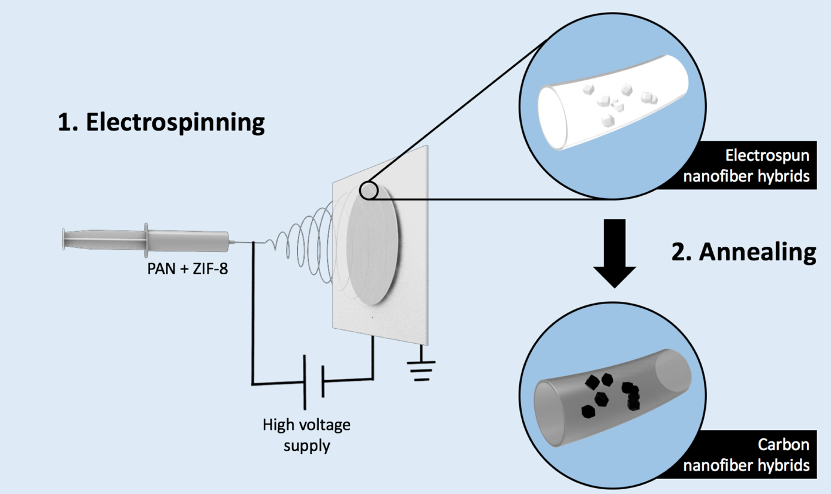

**Figure 2.** FESEM images of (a) CNF, (b) its higher resolution FESEM image and (c) its TEM image; FESEM image of (d) CNFH, (e) its higher resolution FESEM image and (f) TEM image. The insert of (d) is a photograph of our flexible CNFH electrode.

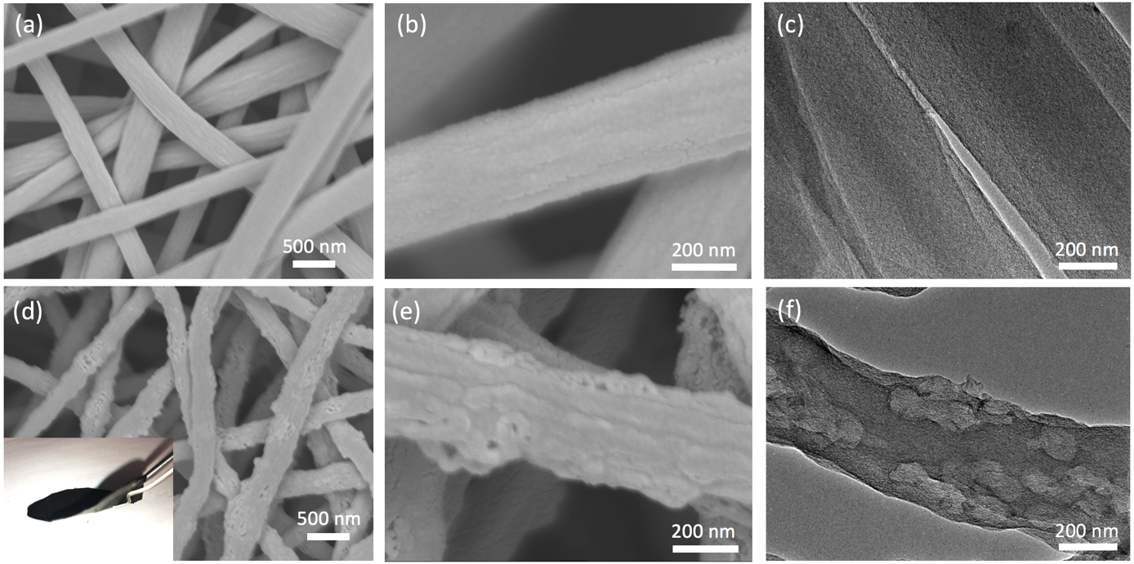

**Figure 3.** (a) XRD patterns, (b) XPS survey spectra, and high resolution N1s spectrum of (c) CNF and (d) CNFH; (e) nitrogen sorption isotherms of CNF and CNFH and (f) BJH pore size distributions.

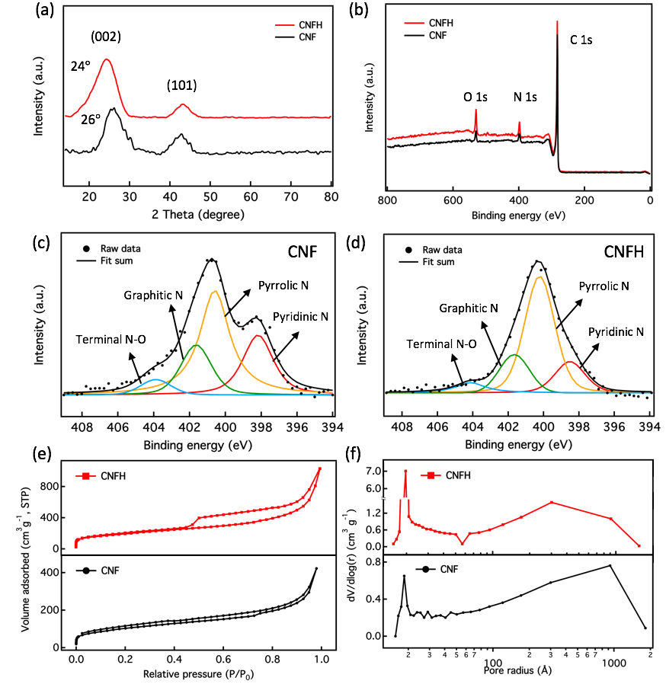

**Figure 4.** (a) CV curves of CNFH in 1 M NaCl solution under different scan rates; (b) CV curves of CNF and CNFH electrodes under a scan rate of 20 mV s-1; (c) specific capacitance comparison of CNF and CNFH; (d) Nyquist plot of CNF and CNFH with an insert of the equivalent circuit.

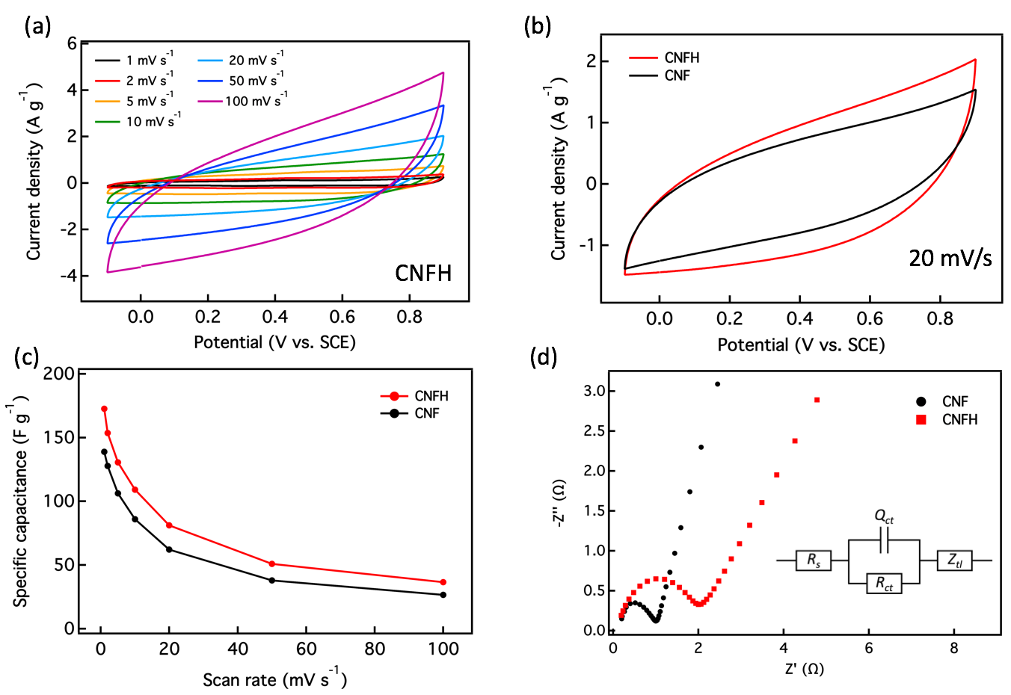

**Figure 5.** (a) Electrosorption behavior of CNF and CNFH in 250 mg L-1 solution at 1.2 V; (b) the electrosorption curve of CNFH in 250 mg L-1 at different cell voltages and its corresponding current; (c) the salt adsorption capacity of CNFH; (d) charge efficiency comparison; (e) cycle performance of CNFH electrode. The error bar indicates the mean ± standard error mean between replicates.

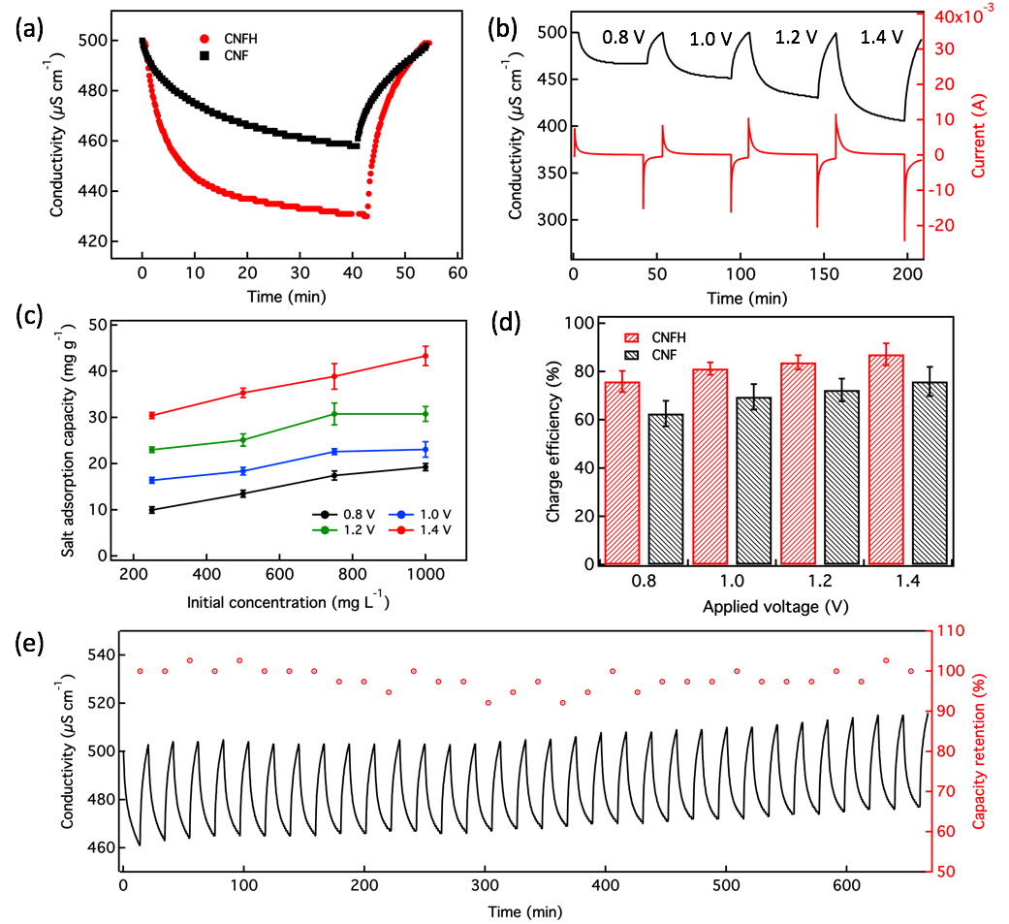

**Figure 6.** (a)The Kim-Yoon plots of CNF and CNFH in 250 mg L-1 solution at 1.2 V, (b) the Kim-Yoon plots of CNFH in 250 mg L-1 solution at different voltages.

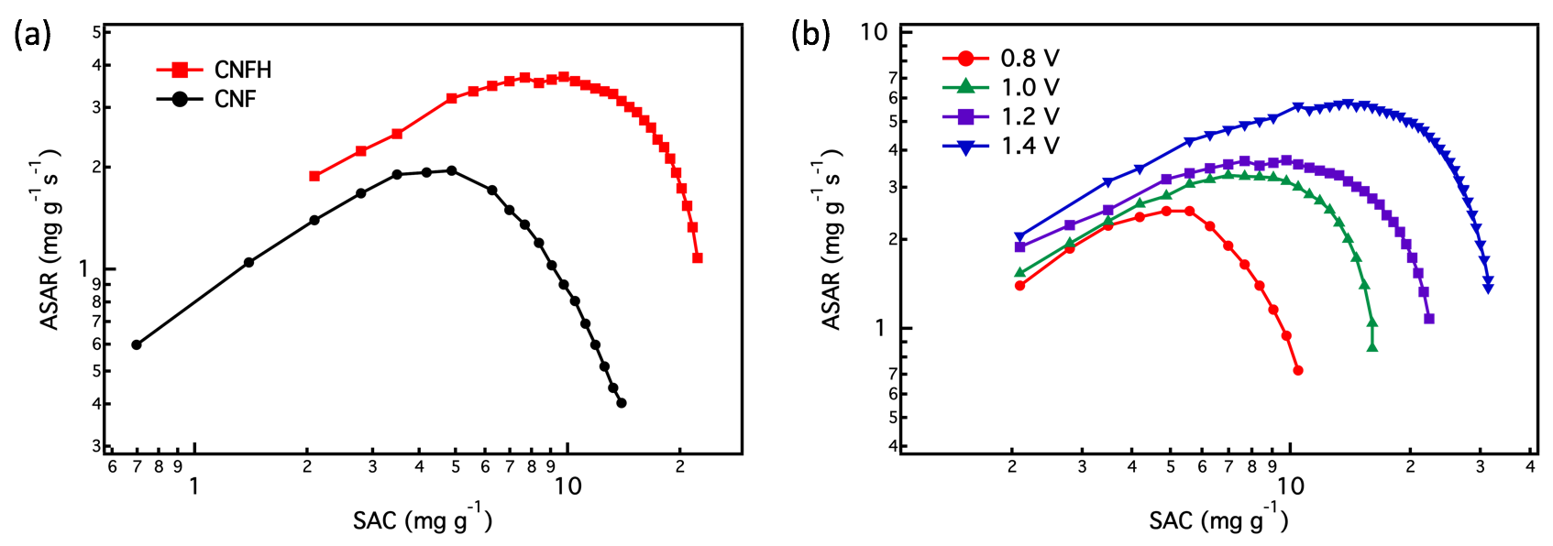

**Table 1.** Salt adsorption capacity comparison

|  |  |  |  |  |  |  |
| --- | --- | --- | --- | --- | --- | --- |
| Sample | Annealing temperature (°C) | Initial concentration (mg L-1) | Voltage (V) | Operation mode | Salt adsorption (mg g-1) | Ref. |
| ZIF-8 derived carbon | 1200 | 500 | 1.2 | Flow-by CDI | 13.86 | [16] |
| ZIF-8/ZIF-67 derived carbon | 900 | 500 | 1.4 | Flow-through CDI | 16.63 | [54] |
| ZIF-8 derived carbon/carbon nanotubes composites | 1000 | 1000 | 1.2 | Flow-by CDI | 20.50 | [17] |
| ZIF-8 derived carbon | 1100 | 750 | 1.4 | Flow-by MCDI | 38.00 | [19] |
| CNFH | 1000 | 500 | 1.4 | Flow-by MCDI | 43.30 | This work |

**This work provides a facial synthesis method to fabricate free-standing electrodes for high-performance membrane capacitive deionization.** By incorporating metal-organic framework nanoparticles with the electrospun nanofibers, the nanofiber composites are able to deliver nitrogen-doped carbon nanofiber hybrids with high surface area and good electrical conductivity. The as-prepared carbon nanofiber hybrid electrodes exhibit an enhanced salt adsorption capacity of 43.3 mg g-1 and a stable long-term performance over 32 cycles.

Keywords: Metal-organic frameworks, Carbon nanofiber hybrid, Membrane capacitive deionization

Meng Ding, Kranthi K.R. Bannuru, Ye Wang, Lu Guo, Fuming Chen, Avinash Baji, Hui Ying Yang*

Free-standing electrodes derived from metal-organic frameworks/ nanofibers hybrids for membrane capacitive deionization

Copyright WILEY-VCH Verlag GmbH & Co. KGaA, 69469 Weinheim, Germany, 2016.

Supporting Information

Free-standing electrodes derived from metal-organic frameworks/ nanofibers hybrids for membrane capacitive deionization

*Meng Ding, Kranthi K.R. Bannuru, Ye Wang, Lu Guo, Fuming Chen, Avinash Baji, Hui Ying Yang\**

**Figure S1.** Temperature profile of the pyrolysis process.

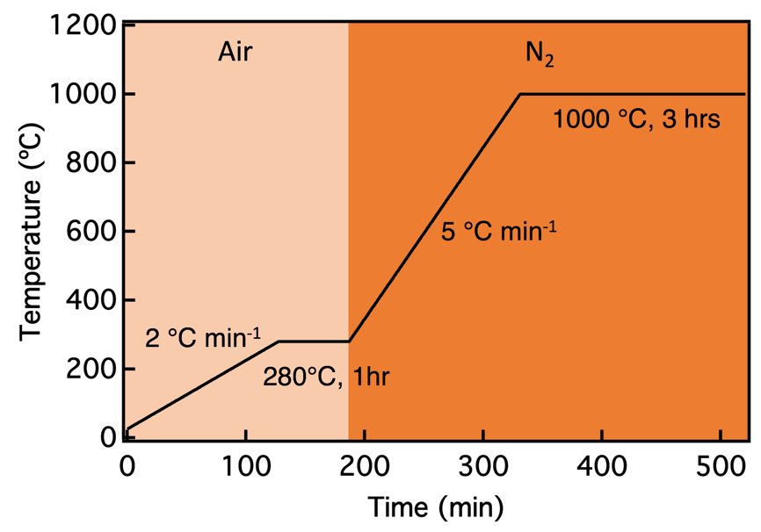

**Figure S2.** XRD pattern of ZIF-8 nanoparticles

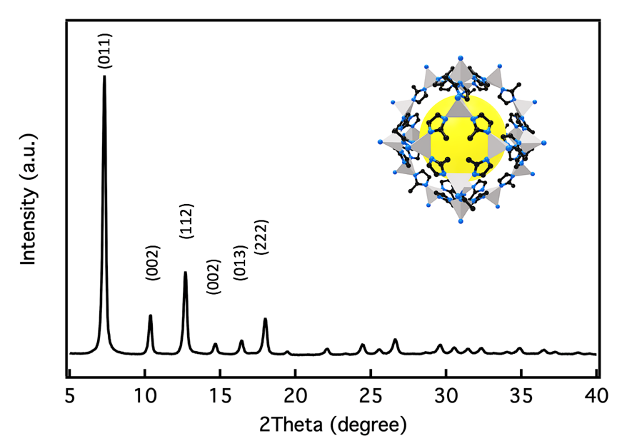

**Figure S3.** High resolution C is spectrum of (a) CNF and (b) CNFH.

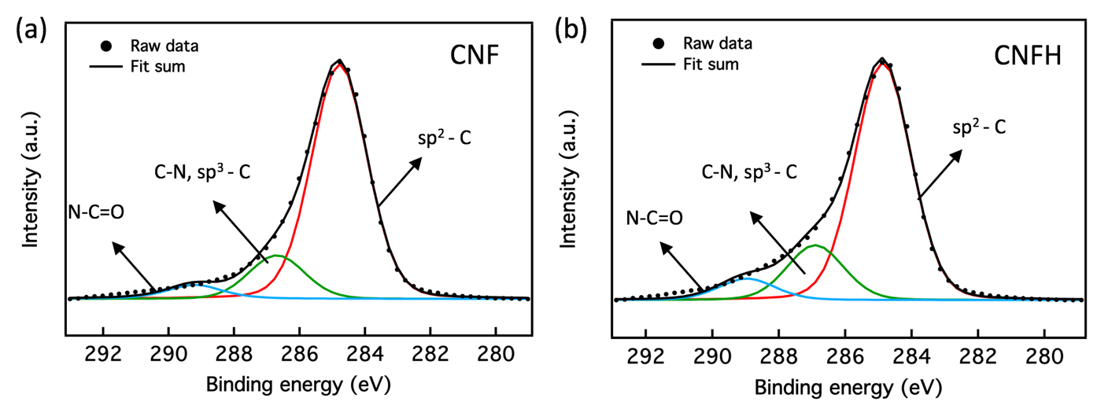

**Figure S4.** CV plots of CNF.

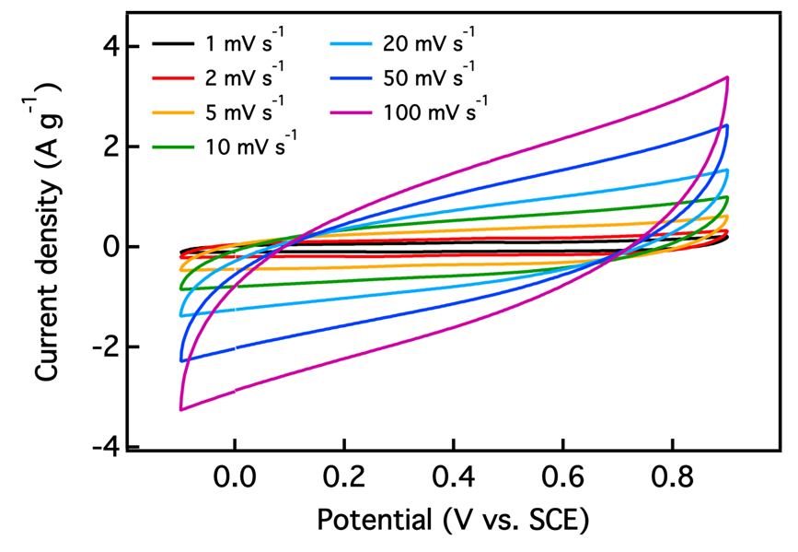

**Figure S5.** Salt adsorption capacity comparison in NaCl solution with the initial concentration of 1000 mg L-1. The error bar represents the mean ± standard error mean between replicates.

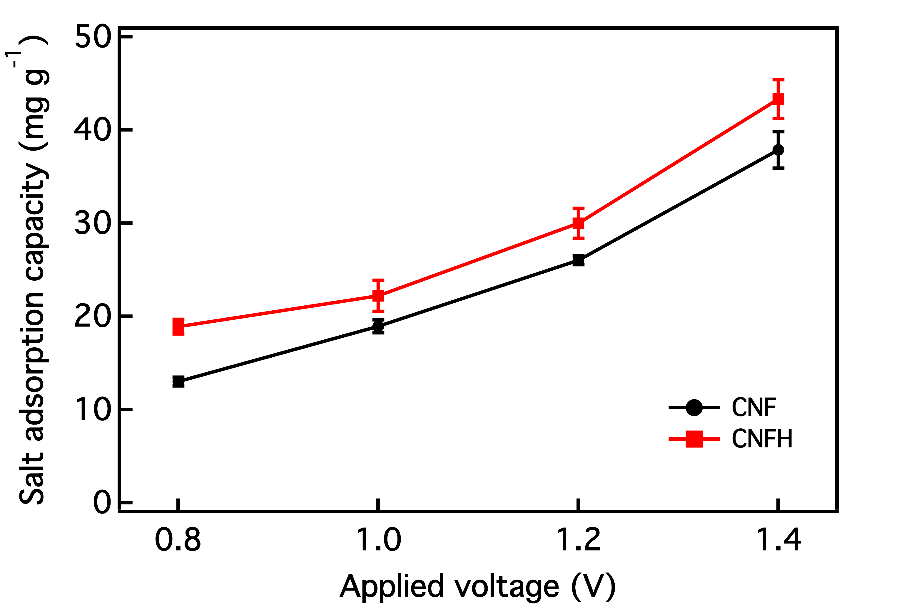

**Figure S6.** Salt adsorption capacity of CNF electrode in various concentration solutions under different applied voltages.

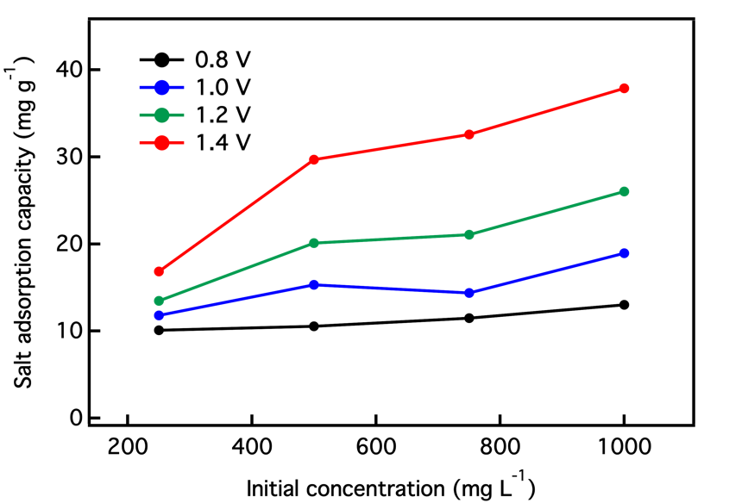

**Figure S7.** Energy normalized adsorbed salt (ENAS) comparison between CNF and CNFH electrodes. The error bar shows the mean ± standard error mean between replicates

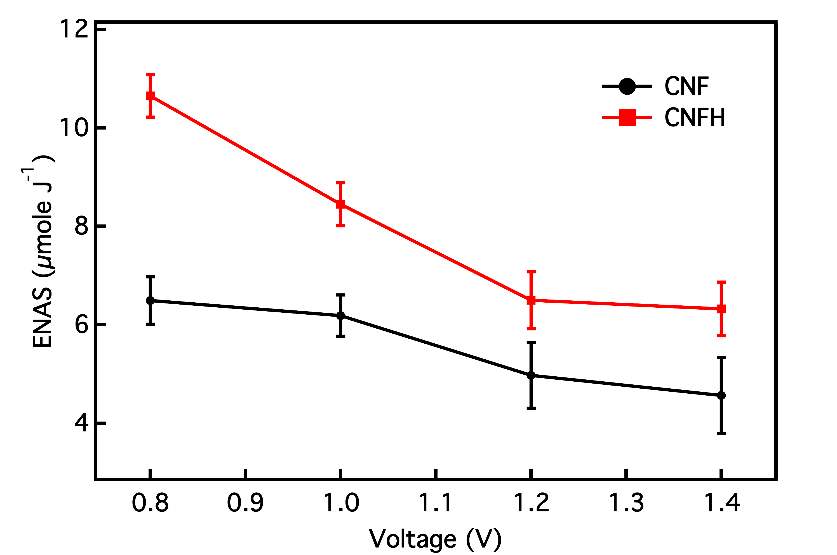

**Table S1.** Characterization parameters of CNFH and CNF.

|  |  |  |
| --- | --- | --- |
| Samples | CNF | CNFH |
| C content (%) | 91.4 | 88.0 |
| N content (%) | 5.2 | 5.4 |
| O content (% | 3.4 | 6.6 |
| Specific surface area (m2 g-1) | 378.8 | 696.2 |
| Average pore size (nm) | 1.851 | 1.966 |
| Pore volume (mL g-1) | 0.762 | 1.499 |

**Table S2.** Specific capacitance results.

|  |  |  |  |  |  |  |  |
| --- | --- | --- | --- | --- | --- | --- | --- |
| **Samples** | **1 mV s-1** | **2 mV s-1** | **5 mV s-1** | **10**  **mV s-1** | **20**  **mV s-1** | **50**  **mV s-1** | **100**  **mV s-1** |
| **CNF**  **(F g-1)** | 138.9 | 127.7 | 106.2 | 86.0 | 62.2 | 37.9 | 26.5 |
| **CNFH (F g-1)** | 172.7 | 153.6 | 130.6 | 109.1 | 81.1 | 50.9 | 36.5 |

**Table S3.** EIS fitting results from the Nyquist plots in Figure 4(d).

|  |  |  |
| --- | --- | --- |
| **Samples** | ***Rs*(Ω)** | ***Rct*(Ω)** |
| **CNF** | 0.18 | 1.16 |
| **CNFH** | 0.19 | 1.81 |

**Table S4.** Charge efficiency of CNF and CNFH at different initial concentration solutions.

|  |  |  |  |  |
| --- | --- | --- | --- | --- |
| Initial concentration (mg L-1) | 250 | 500 | 750 | 1000 |
| CNF (%) | 62.61 ± 5.25 | 69.52 ± 5.25 | 72.39 ± 4.67 | 75.93 ± 6.05 |
| CNFH (%) | 75.90 ± 4.38 | 81.27 ± 2.56 | 83.81 ± 2.98 | 87.13 ± 4.57 |